A successful 30-turn “conversation” done between the chat bot and tester: (The captures are in order) 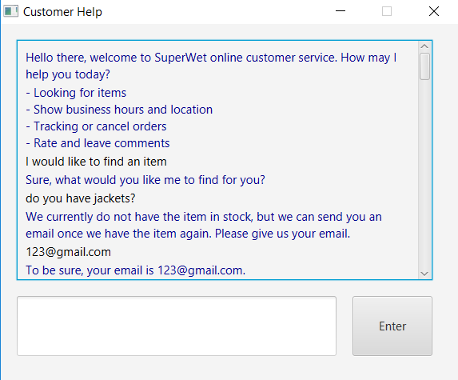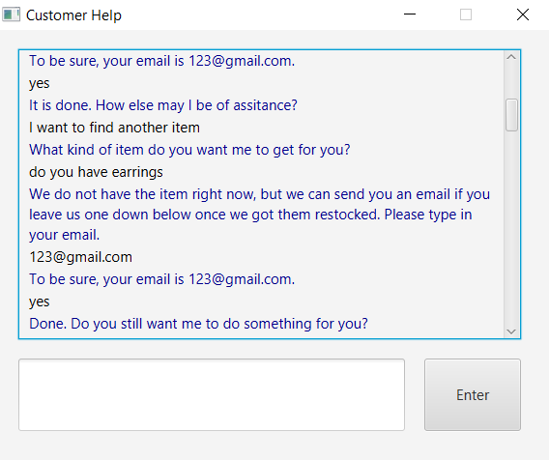

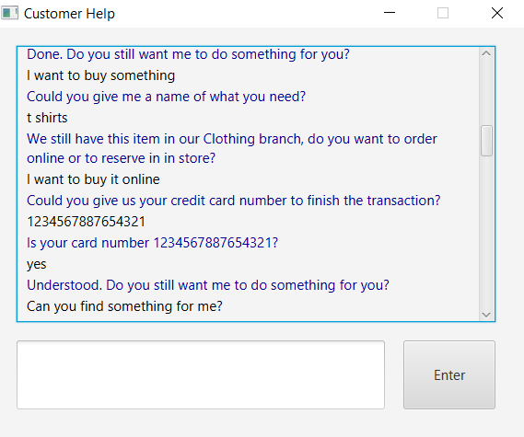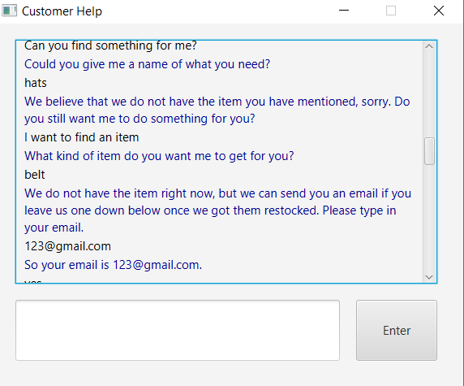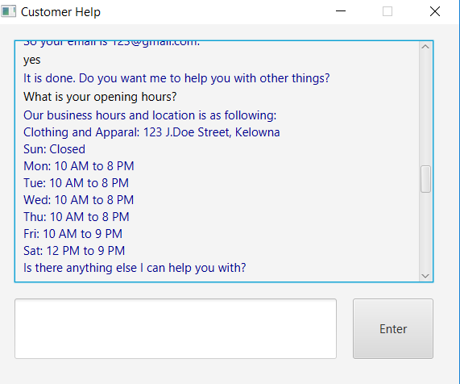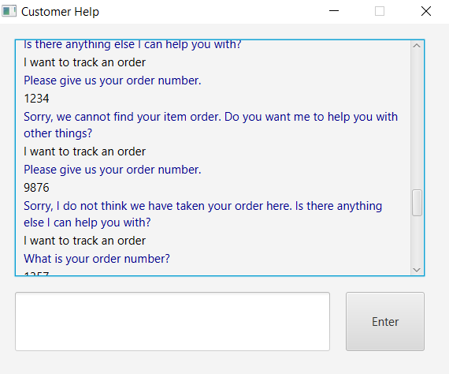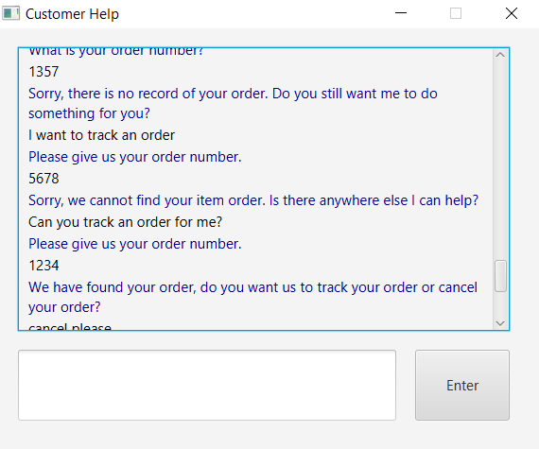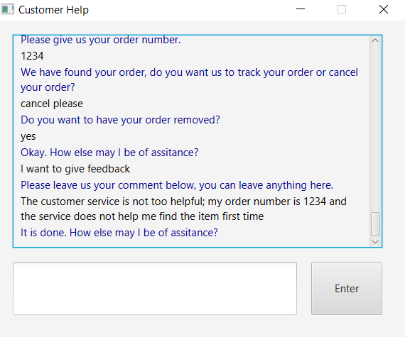

Issues with the chat-bot:

The spell-checking only works on minor spelling errors. Larger ones, like swapped characters, do not work well in this spell-checking algorithm.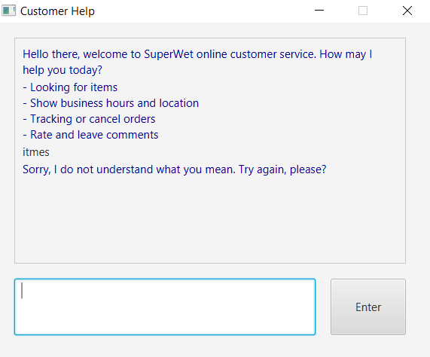

Sometimes, the conversation is not as smooth as it should be, and some responses are a little off. (e.g. The bot does not remember my name, and does not tell me that they have reserved an item for me.) 